**BÀI ÔN TATC KHỐI 3 LẦN 5**

**TUẦN TỪ 30/3 ĐẾN 3/4/2020**

**Exercise 1:**

**THINGS IN BILLY’S BEDROOM**

Max and Sue see many things in Billy’s bedroom. Draw a line from the pictures of the things to the words. The first one is an example.

Be careful. There are two extra words.

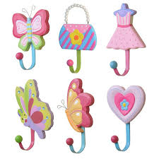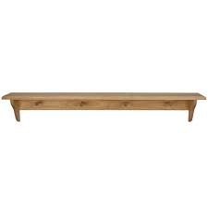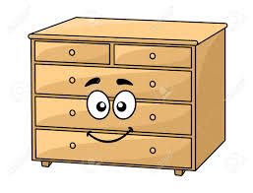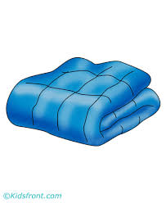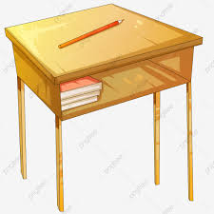

bear

drum

picture

drawers

coat hooks

pillow

rug

shelf

desk

computer

blanket

**Exercise 2:**

**THINGS AT THE PARK**

Tim and Rosy take Billy and John to the park. They see many things there. Draw a line from the pictures of the things to the words. The first one is an example.

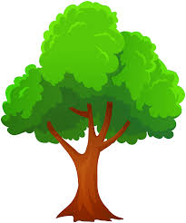Be careful. There are two extra words.

slide



frog

plane



kite



boat

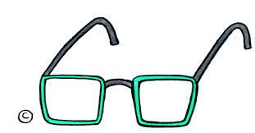

tree



glasses



chicken

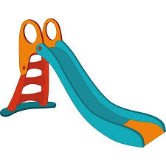

camera



duck

**Exercise 3:**

**Kate and Benny**

Sophie is at Kate and Benny’s house. She is writing in her diary. Help Sophie to finish and write the missing words. Use the words in the box.

Be careful. You do not need all of them. The first one is an example.

|  |
| --- |
| is sister’s got at not  and eating nice **~~my~~**  with in |

Kate is **my** new friends. She (1)………………. a girl at school. Kate has got a sister but she has (2) ……………………… got a brother. Her (3)……………………. name is Bella. Jack (4) ………………….. I are at her house now. Bella and Jack are (5) ………………… sandwiches in the dining room. Kate and I are talking (6) ………………….. the kitchen. We are having a (7)…………………….. time.

**Exercise 4:**

**My Dad’s friend**

Ben writes in his diary about Dan and his family. Help him to finish and write the missing words. Use the words in the box.

Be careful. You do not need all of them. The first one is an example.

|  |
| --- |
| very not rooms have His  them has **~~my~~** They bathrooms There |

Mr Dan is **my** dad’s friend. He’s got a fantastic family. (1).……………………… wife is kind and the children are (2)…………………….. friendly. I like (3)……………………. very much. Mr Dan (4)…………………… a lot of money and his house is very big. (5)………… are four bedrooms, two living rooms, two (6)………………… and a big kitchen. There is a beautiful garden too, but it has (7)…………………… got many flowers in it.

**Exercise 5:**

**My new music teacher**

Harry writes in her diary about Mrs Green. Help her to finish and write the missing words. Use the words in the box.

Be careful. You do not need all of them. The first one is an example.

|  |
| --- |
| has is play not her  colour There school but They name |

There is a new teacher in our **school**. Her (1)……………… is Mrs Green. She (2)……………….. my new music teacher. She’s very friendly. I like (3)………………. very much. She can (4)……………… the piano and the guitar. Mrs Green’s house is (5)……………… very big. (6)……………. are two bedrooms, a living room, a kitchen and a bathroom. The garden is small too, (7)………………… there are nice trees and flowers in it.

**Exercise 6:**

Read this. Choose a word from the box. Write the correct word next to numbers 1-5. There is one example.

|  |
| --- |
| ~~tree~~  cats door eggs  songs legs sand tail |

A bird

I live in a **tree** or on water. My babies come from small (1)………………… . I have got a (2)……………………. at the end of my body. I can walk on my two (3)………………….. . I sing beautiful (4)………………………. . Some (5)………………….. catch me.

What am I? I am a bird.

**Exercise 7:**

**Sue talks to Ben**

Sue talks to Ben about her new music teacher, Mrs Brown. Draw a line from Ben’s questions to Sue’s answers. The first one is an example.

Be careful. There is one extra answer.

|  |  |  |
| --- | --- | --- |
| Example: Do you like Mrs Brown, Sue? |  | 1. Tomorrow at ten in the morning. |
| 1. How old is Mrs Brown? | 1. English isn’t my favorite lesson. |
| 1. Can she play the guitar? | 1. Yes, she’s a fantastic teacher. |
| 1. When is your next piano lesson? | 1. Yes, but I like maths, too. |
| 1. Is music your favourite lesson at school? | 1. It’s a long way from us, next to the museum. |
| 1. Where is Mrs Brown’s house, Sue? | 1. Yes, and she can sing well, too. |
| G I’m not sure but she’s not very old. |

**Exercise 8:**

**Harry’s mum talks to Katy.**

Harry’s mum comes for Harry and Tim at the end of Fred’s party. She asks Karen some questions. Draw a line from the questions to Karen’s answers. The first one is an example.

Be careful. There is one extra answer.

|  |  |  |
| --- | --- | --- |
| Example: Are you in Harry’s class, Karen? |  | 1. Thirteen girls and fourteen boys. |
| 1. Who is your teacher? | 1. Yes, but she’s not my favourite teacher. |
| 1. Do you like her? | 1. No. I’m not. |
| 1. How many children are there in your class? | 1. Yes, I am, but I can’t play soccer well. |
| 1. What is your favourites sport at school? | 1. Badminton. But I like soccer, too. |
| 1. Are you good at badminton? | 1. Yes, there are twenty. |
| 1. Her name is Mrs Ball. |

**Exercise 9:**

**Sophie talks to Angie about her school.**

In the garden, Sophie asks Angie about her school. Draw a line from Sophie’s questions to Karen’s answers. The first one is an example.

Be careful. There is one extra answer.

|  |  |  |
| --- | --- | --- |
| Example: where is your school? |  | 1. I don’t know but she’s young. |
| 1. Do you like your school? | 1. Mrs Jerry. She is my maths teacher. |
| 1. Who is your favourite teacher? | 1. It’s next to my house. |
| 1. How old is Mrs Green? | 1. Yes, it’s my favourite subject. |
| 1. Do you like maths? | 1. Boys don’t like math. |
| 1. How many boys are there in your class? | 1. Yes, the teachers are fantastic. |
| 1. Fifteen. And there are fourteen girls. |

**Exercise 10: Look and read. Write *Yes* or *No*.**

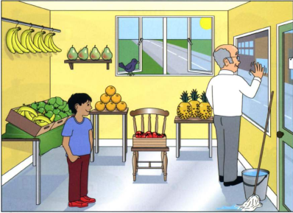

**Examples:**

There are tomatoes on the chair. ……***Yes***….……………….

The bananas are between the two windows. ……***No*.**.………………….

**Questions:**

1. There are six oranges. …………………………….
2. The floor is very dirty. …………………………….
3. The old man is sad. …………………………….
4. The pears are on the table. …………………………….
5. The boy is wearing red shoes. …………………………….

**Exercise 11: Write in words and complete the sum.**

1. 5 + 10 = ? *five and ten is fifteen.*
2. 20 + 40 = ? ……………………………………………………………
3. 60 + ? = 90 ……………………………………………………………
4. 80 + ? = 100 ……………………………………………………………
5. 15 + ? = 50 ……………………………………………………………
6. ? + 40 = 60 ……………………………………………………………